Economics Experimental Design & RCT Simulator – Summary
Adapted from Clinical Trial Randomization Simulator for Experimental Economics, RCTs & Causal Inference

Problem Statement:
Causal claims in economics rest on the ability to isolate the effect of an intervention from selection and confounding. Randomized assignment of subjects to treatment and control is the gold-standard solution, yet students often underestimate how easily bias creeps in when allocation is not properly randomized. This project turns the mechanics of random assignment into an interactive teaching tool that makes the consequences of fair versus biased allocation visible through Monte-Carlo simulation.

Solution Strategy:
1. Implement four allocation methods: simple randomization, permuted-block, always-Treatment (extreme selection bias), and sequential alternation.
2. Provide a single-experiment summary (counts, % Treatment, imbalance) and a Monte-Carlo engine that repeats the process thousands of times.
3. Visualize the resulting distributions so learners see which methods stay balanced and which introduce systematic bias.
4. Expose tunable parameters (N, number of replications, method, ratio) so students can experiment with design choices typical of economic experiments and field RCTs.

Solution:
Files: Economics_Experimental_Design_RCT_Practice_Skeleton.ipynb • Economics_Experimental_Design_RCT_Solution.ipynb
• economics_rct_flowchart.png • economics_rct_simulation.png • this 1-page report
Key result from 2 000 simulated experiments of N = 100: Simple randomization centres on 50 % with SD ≈ 5 %; block randomization is essentially perfect; “Always Treatment” is 100 % biased; sequential alternation looks balanced but is fully predictable and therefore invalid for causal inference.
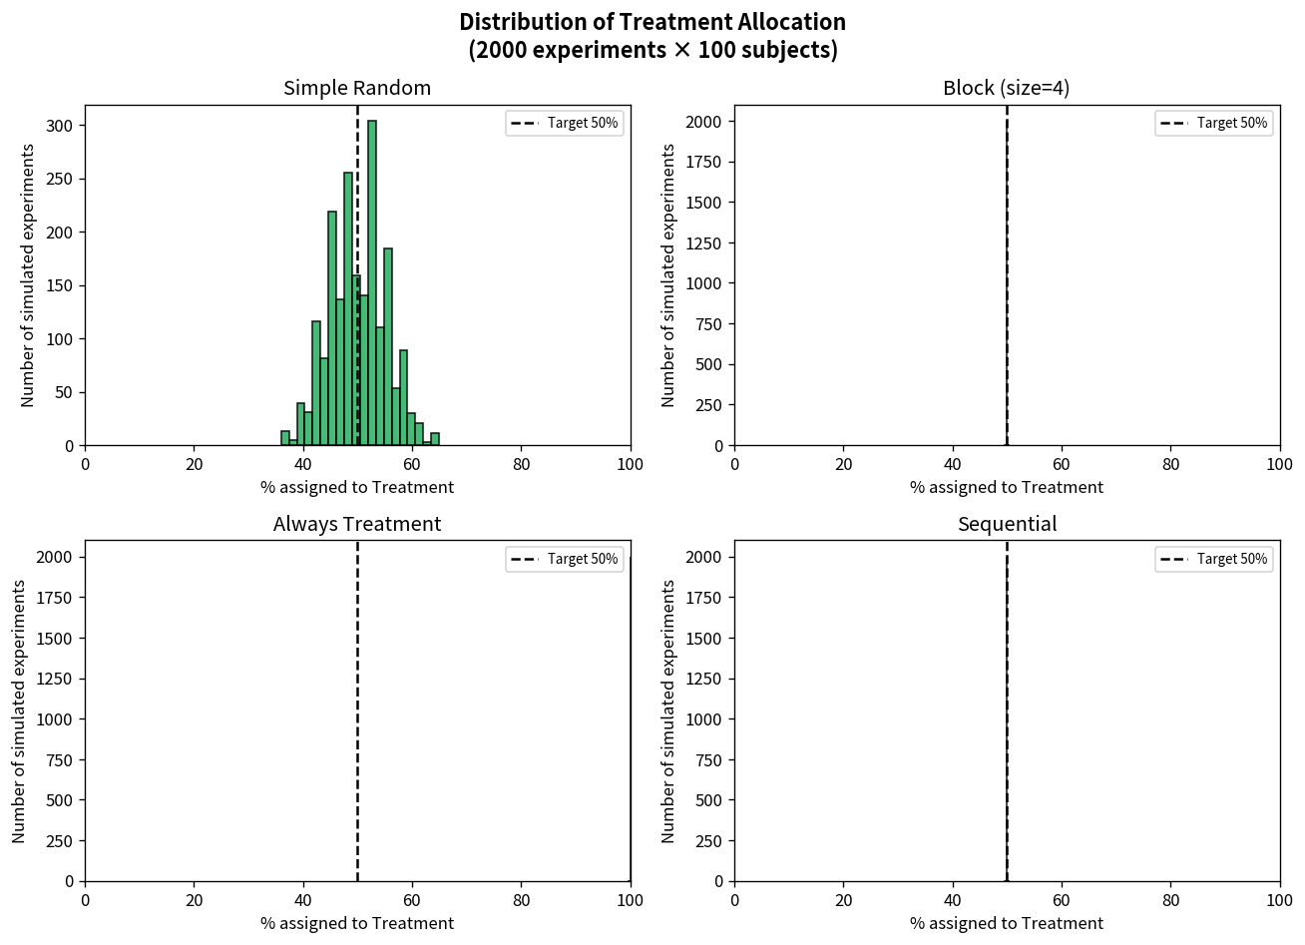

Key Takeaways:
• Proper randomization (simple or blocked) keeps expected allocation on target and limits chance imbalance.
• Deterministic strategies create systematic imbalance — the educational analogue of selection bias that invalidates causal claims.
• Larger samples sharply reduce the probability of large chance imbalances under simple randomization.
• Monte-Carlo simulation is the same technique used in power calculations and pre-analysis plans for real economic experiments and RCTs.
• The programming patterns from simple games and clinical-trial tools transfer directly to rigorous training in experimental economics and RCT design.

